OT Overview Devotions Week 22: Revelation 21-22

Day 1

Take a moment to recall how the Old Testament account ends in the book of Nehemiah. Praise God for the restoration he has brought in bringing Israel back to their land with the temple and city restored! Yet, recall also the disappointment we felt with Nehemiah and with the returning exiles of Israel.

Imagine what it would be like as an Israelite to await the “circumcision of your hearts” and God’s gift of a new heart and a new spirit (Ezekiel 36:26). How would you have understood this mystery or imagined it to be fulfilled? Talk to God about this glorious promise. Thank Him that we can ‘look backwards’ and think about this with the privilege of knowing Christ and God’s promises fulfilled!

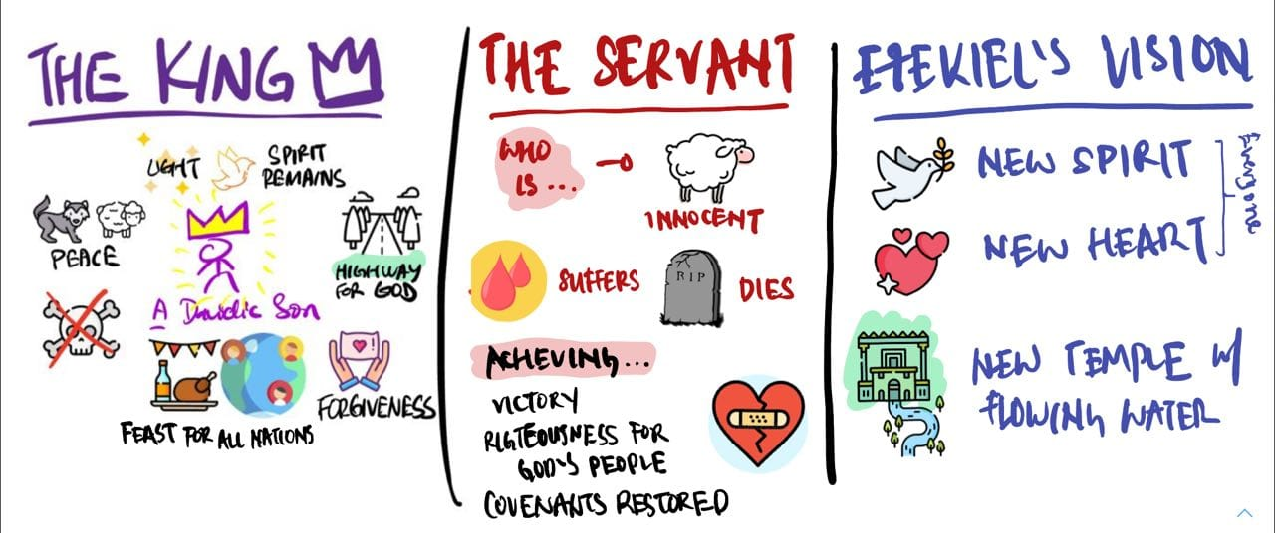

Day 2

In this final wrap-up session, we want to reflect upon and delight in all the wonderful ways in which God’s realises all His covenant promises in the person and work of the Lord Jesus.

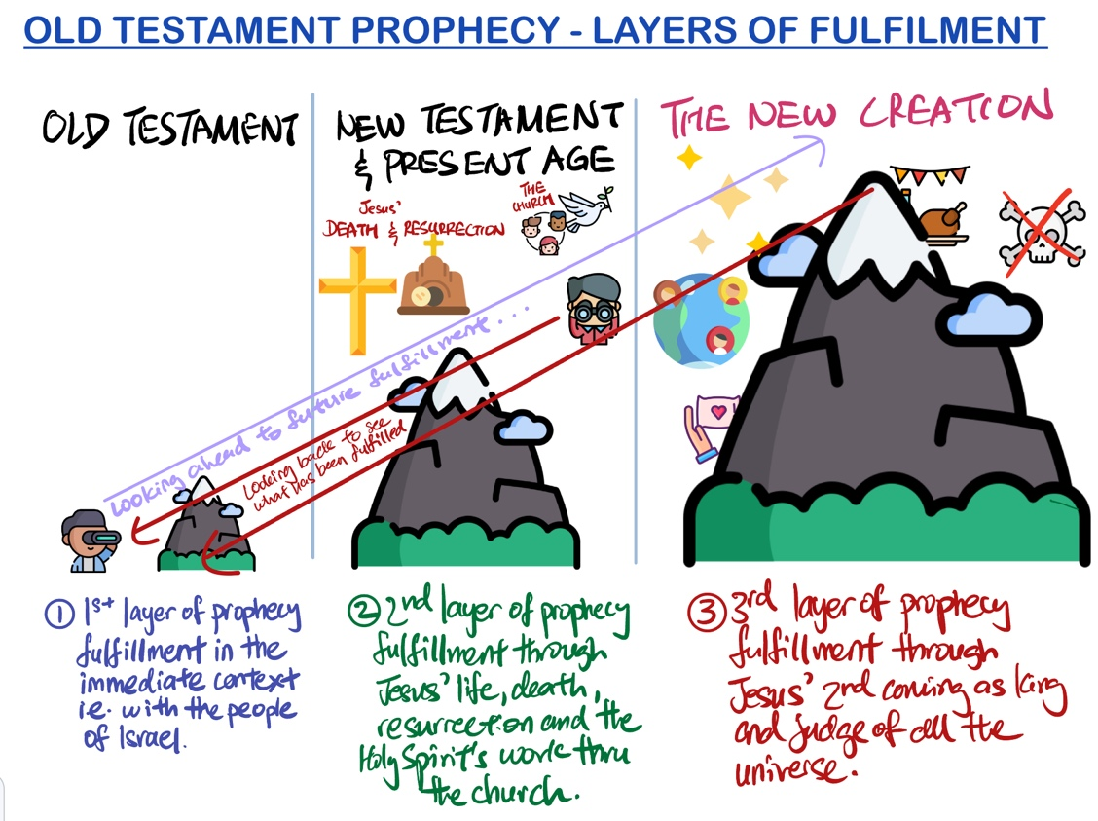

The diagram above is one way in which we can better understand the covenant promises and prophecies of God in the Old Testament. They are fulfilled in a few ways, and ultimately in the new creation when Christ returns and rules as king of all.

Recall or browse through portions of New Testament such as (a) Gospel of John and (b) Paul’s letter to the Ephesians that state or tell you how Jesus fulfils some of these OT covenant promises.

Day 3

Browse through other NT passages that you have not considered and think about how Christ is said to have fulfilled God’ ancient promises.

Set aside some time to pray over the various NT passages you have looked at. What are you thankful to God for about Jesus as our King? How have you grown in your understanding of the Temple theme throughout the Bible (and how we the church are now considered the temple of the Holy Spirit – Ephesians 2)?

Day 4

Read Revelation 21-22. What are some of the Old Testament promises/covenants we have reflected upon in the past year you see being fulfilled here?

Look back at some of these OT passages and reflect upon about how they are being fulfilled in Christ. Speak to our Father and thank Him for keeping His word!

Day 5

Look back at some of your reflections and notes in the past week. Take time to speak to God about what He’s impressed upon your heart and thank Him for the great gift of His Son and His Spirit to us His church!

